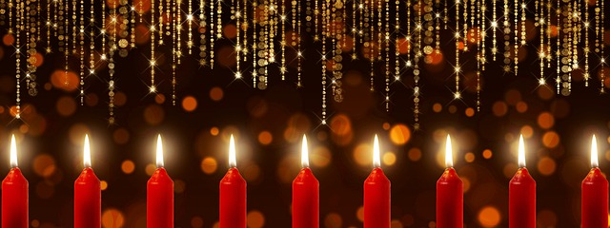
Lessons and Carols Program – December 11, 2022
Organ Prelude – Pastoral Symphony from George Frideric Handel’s Messiah
Welcome – Rev. Cheryl Fox
Carol– The First Noel (all sing – the organ will play the carol through once)
The First Noel the Angels did say
Was to certain poor shepherds in fields as they lay
In fields where they lay keeping their sheep
On a cold winter's night that was so deep.
Noel Noel Noel Noel
Born is the King of Israel!
They looked up and saw a star
Shining in the East beyond them far
And to the earth it gave great light
And so it continued both day and night.
Noel Noel Noel Noel
Born is the King of Israel!

First Lesson - Genesis 2:4b-9, 15-25 – Patty Williams, Reader
Bring Us Hope – Choir
Second Lesson - Isaiah 40: 1-11 - Tim Brookshire, Reader
Coventry Carol – Choir, Patty Williams, soprano
Third Lesson - Jeremiah 31: 31-34 - Linda Barcus, Reader
Ashokan Farewell - Kelsey Petterson, violin
Fourth Lesson - Isaiah 7: 10-15 - Martha Simoneau, Reader
All On A Silent Night - Choir
Fifth Lesson - Micah 5: 2-4 – Martha Simoneau, Reader
Carol – O Little Town of Bethlehem (all sing – the organ will play the carol through once)
O little town of Bethlehem, how still we see they lie!
Above thy deep and dreamless sleep the silent stars go by;
Yet in thy dark streets shineth the everlasting light.
The hopes and fears of all the years are met in thee tonight.

For Christ is born of Mary, and, gathered all above
while mortals sleep, the angels keep their watch of wond’ring love.
O morning stars, together proclaim the holy birth,
And praises sing to God the kind, and peace to all the earth!

Bring A Torch, Jeannette Isabella – Quartet
Sixth Lesson - Isaiah 11: 1- 9 – Dorinda Harbeson, Reader
Night of Wonder – Choir and violin, Kelsey Petterson
Seventh Lesson - Zephaniah 3: 14-18 – Linda Barcus, Reader
Silent Night – Quartet
O Holy Night - piano solo, Beth LaGro
Eighth Lesson - Isaiah 65: 17-25 – Pastor Cosette Riggs, Reader
Still, Still, Still – Choir
Ninth Lesson - Luke 1: 26-38 – Kris Vasquez, Reader
Carol – O Come All Ye Faithful – violins, guitar and organ will play first time through, and then all join in and sing:
O come, all ye faithful, joyful and triumphant!
O come ye, O come ye to Bethlehem;
Come and behold him, born the kinf of angels:
O come, let us adore him. O come, let us adore,
O Come, let us adore him, Christ the Lord.

Sing, choirs of angels, sing in exultation,
Sing, all ye sitizens of heaen above!
Glory to God in the highest:
O come, let us adore him. O come, let us adore,
O Come, let us adore him, Christ the Lord.

Prayer and benediction
Organ postlude – Joy to the World

Reception follows in Walker Hall
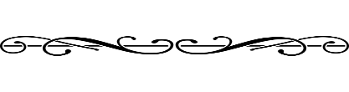
Choir Members: Dorinda Harbeson, Margaret Hangan, David Mills, Debra Noel, Patty Williams, Ken Malpas, Pam Hendrickson, and Joe Hendrickson
Violins: Kelsey Petterson, Dorinda Harbeson, Patty Williams
Guitar: David Mills
Piano/organ: Elizabeth LaGro

